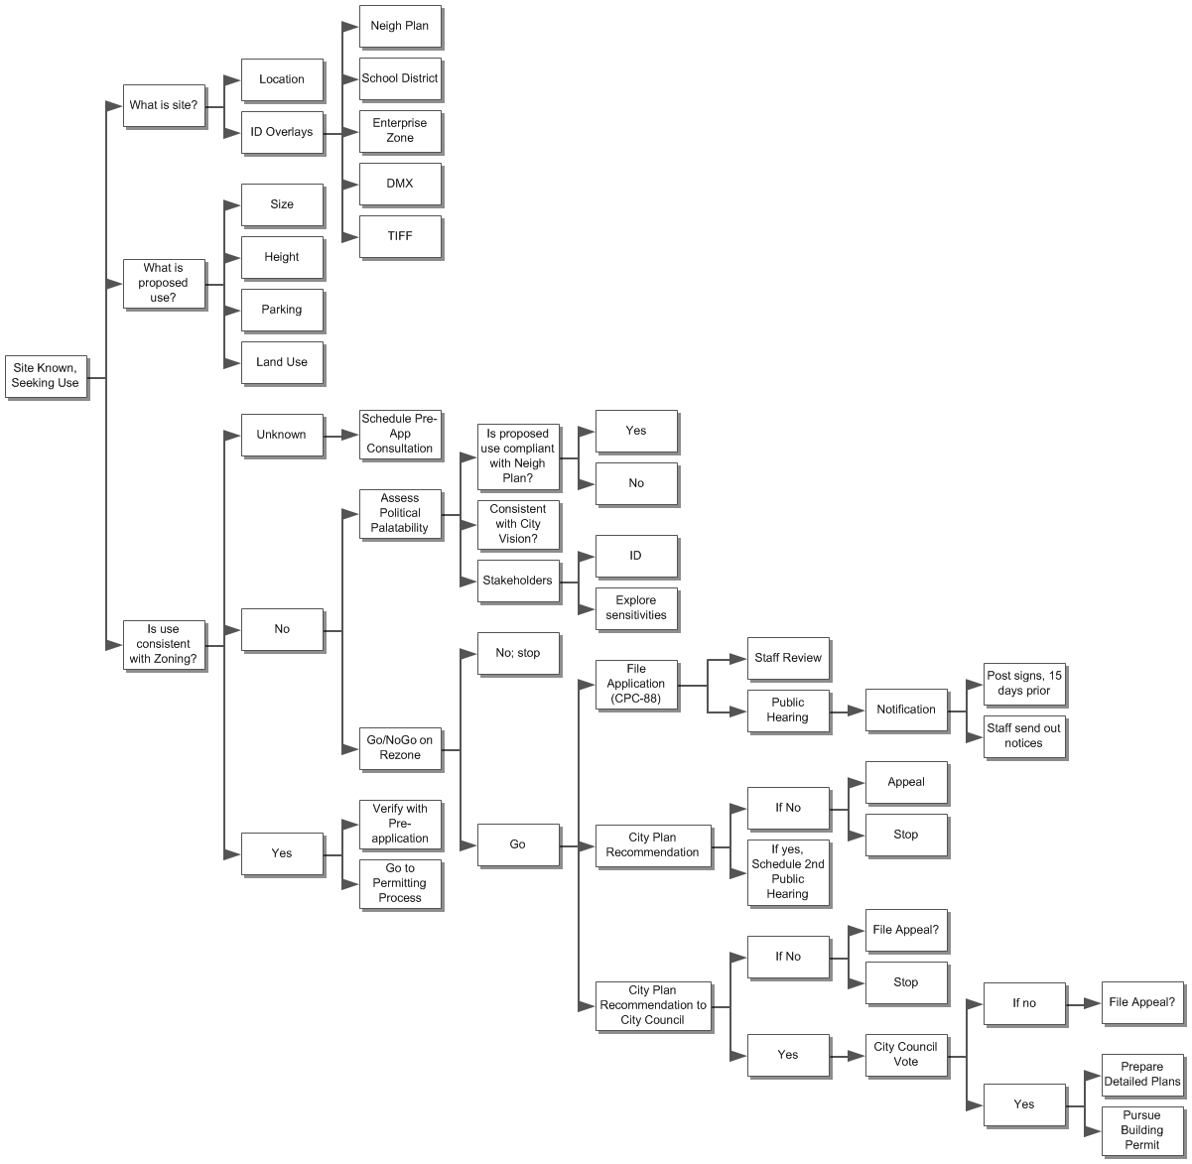

**Site Known, Seeking Use**

**I.** **What is site?**

**A.** **Location**

**B.** **ID Overlays**

**1.** **Neigh Plan**

**2.** **School District**

**3.** **Enterprise Zone**

**4.** **DMX**

**5.** **TIFF**

**II.** **What is proposed use?**

**A.** **Size**

**B.** **Height**

**C.** **Parking**

**D.** **Land Use**

**III.** **Is use consistent with Zoning?**

**A.** **Unknown**

**1.** **Schedule Pre-App Consultation**

**a.** **ID needed Info**

**b.** **Compile needed info**

**c.** **Prepare for Meeting**

**B.** **No**

**1.** **Assess Political Palatability**

**a.** **Is proposed use compliant with Neigh Plan?**

**(1)** **Yes**

**(2)** **No**

**b.** **Consistent with City Vision?**

**c.** **Stakeholders**

**(1)** **ID**

**(2)** **Explore sensitivities**

**2.** **Go/NoGo on Rezone**

**a.** **No; stop**

**b.** **Go**

**(1)** **File Application (CPC-88)**

**(a)** **Staff Review**

**(b)** **Public Hearing**

**i)** **Notification**

**(1)** **Post signs, 15 days prior**

**(2)** **Staff send out notices**

**(2)** **City Plan Recommendation**

**(a)** **If No**

**i)** **Appeal**

**ii)** **Stop**

**(b)** **If yes, Schedule 2nd Public Hearing**

**(3)** **City Plan Recommendation to City Council**

**(a)** **If No**

**i)** **File Appeal?**

**ii)** **Stop**

**(b)** **Yes**

**i)** **City Council Vote**

**(1)** **If no**

**(a)** **File Appeal?**

**(2)** **Yes**

**(a)** **Prepare Detailed Plans**

**(b)** **Pursue Building Permit**

**C.** **Yes**

**1.** **Verify with Pre-application**

**2.** **Go to Permitting Process**